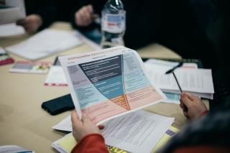
g
Session Dates:
Session 1- 15th & 16th September
Session 2 - 28th & 29th September
Session 3 -13th & 14th October
Session 4 - 21st & 22nd October
Session 5 - 10th & 11th November
Session 6 - 18th & 19th November
Time: 10:30 am – 1.00 pm
(please arrive at 10.15 am)
Venue: Via Zoom Online
RSVP: Places are limited.
Register on Eventbrite - see page 2 for links

This training is targeted at Tier 2 & Tier 3 agencies
This training is not intended to provide risk assessment training, but compliments other MARAM modules that will be available in 2020.
All participants are required to read the MARAM Foundation Knowledge Guide and watch the Helping end family violence film before attending.
MARAM = Multi-Agency Risk Assessment and Management
Join colleagues who respond to family violence at this inaugural training over two consecutive days. The training focuses on both collaborative practice and the foundational aspects of MARAM that enable collaboration. Professionals will explore how to contribute to risk assessment and collaborate for ongoing risk management, through respectful and sensitive engagement with victim survivors, information sharing, referral and secondary consultation.

The traiing is for Tier 2 & 3 a
Collaborative Practice Training:
Putting the multi-agency into MARAM
MARAM Collaborative Practice Training is now available to
professionals across the South West Western District Region.

To complete the course both days must be attended
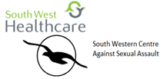

Session 1- 15th & 16th September | https://www.eventbrite.com.au/e/118253470313
Session 2 - 28th & 29th September | https://www.eventbrite.com.au/e/118254017951
Session 3 -13th & 14th October | https://www.eventbrite.com.au/e/118254140317
Session 4 - 21st & 22nd October | https://www.eventbrite.com.au/e/118254288761
Session 5 - 10th & 11th November | https://www.eventbrite.com.au/e/118254657865
Session 6 - 18th & 19th November | https://www.eventbrite.com.au/e/118254908615

